2017 Teens’ Top Ten Survey Winners
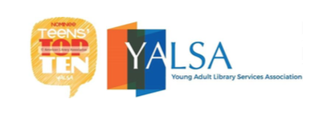
No one correctly chose Don’t Get Caught: Let the Prank War Begin as the number one book on the 2017 Teens’ Top Ten so there is no grand prize winner.

However, Emma Ortiz correctly picked six of the ten books chosen for the list. She also selected the top three books as part of her choices. She will receive a $15.00 dollar gift card from Barnes and Noble.

Ryan Evans also correctly picked six of the ten books. He will receive a $10.00 gift card from Barnes and Noble as his prize.

The following students correctly selected five of the top ten books and will receive a prize:
- Kishan Patel
- Addie Keenan
- Summer Miller
- Jessica Morris
- Samira Velazquez
- Marini Spirollari
- Leah Shell
- Gracie Moyers
- Laney Biddle
- Nickolas Boychenko
- Nalen Ramos

The following student also will win a prize for checking out one of the Teens’ Top Ten books during Teen Read Week.
- Emily Rees
- Richard Jarrells
- Isabella Bolyard
- Morgan Ritchie
- Duaa Ahmed
- Adeline Riner

